**Title:** Dissolved Organic Matter (DOM) Removal from Drinking Water with PACl, Clay, and Activated Carbon

**Team:** Dissolved Organic Matter, Fall 2022

**Names:** Rachel Lai, Nhi Nguyen, Zachary Kwon, Brooke Paykin, Mateo Aranzazu

**Date:** 5 December 2022

**Abstract**

The Fall 2022 Dissolved Organic Matter subteam aims to compare the effectiveness of implementing polyaluminum chloride (PACl) with powdered activated carbon (PAC) and/or clay to remove humic acid from drinking water. To ascertain the optimal amounts of i) activated carbon and ii) clay concentration, the following parameters will be fixed in the experiments: concentration of humic acid, run-time, and H2O flow rate. Both activated carbon and clay are predicted to increase the density of flocs, but this subteam plans to determine which is more effective at creating high-density flocs for removal in the sedimentation tank. Through performing research regarding the optimal concentration of activated carbon and/or clay, DOM subteam hopes to improve the capability of AguaClara water treatment plants.

**Introduction**

Dissolved organic matter, a natural transparent water contaminant, is present in unusually high amounts in AguaClara’s plant in Gracias, Honduras. DOM is created from the decomposition of organic matter, such as feces and decaying leaves. When DOM reacts with coagulants like polyaluminum chloride, the contaminants clump together into flocs, which are more easily removed in the filtration process.

However, to remove DOM by means of flocculation, it is essential that flocs form with a relatively high density, preferably higher than that of water. If the reverse were the case, flocs would float to the surface of the water, causing difficulty in floc blanket formation and filtration in steps subsequent to flocculation.

One method to achieve high density flocs that are more prone to settlement is through pre-combining kaolin clay with coagulant solution prior to the flocculation step (Wu et al., 2020). Clay can be used to simulate the turbidity of influent water and promote coagulation by adhering to the surface of coagulant and attracting DOM by means of collision aggregation.

An alternative to kaolin clay would be powdered activated carbon, which can be combined with humic acid and water prior to the introduction of coagulant (Tafvizi et al., 2021). Due to its porous surface, activated carbon particles, once bound onto coagulant particles, have the capability to adsorb a large amount of dissolved organic matter onto its surface. This ability helps to increase the effectiveness of the coagulant, reduce coagulant dosage, and create heavier flocs.

This semester, the Dissolved Organic Matter subteam is investigating the effectiveness of implementing coagulant with clay and/or powdered activated carbon in removing humic acid from influent water. Future steps in this experiment include examining the optimal dosage of coagulant with clay and/or activated carbon and the financial trade-offs between the two.

**Literature Review**

Clay is important in modeling the removal of dissolved organic matter in water due to its ability to produce turbidity. In a 2021 article by Saxena et al., researchers modified a model for hydraulic flocculators and tested for a sludge blanket clarifier by running experiments using synthetic water samples consisting of humic acid and kaolin clay, and poly aluminum chloride as a coagulant. The reasoning behind the use of clay in the procedure of removing dissolved organic matter is that it is a major contributor to inorganic turbidity in surface waters due to the fact that it is larger than poly aluminum chloride nanoparticles. Since turbidity is measured by the amount of light scattered or blocked by suspended particles in a water sample, large particles such as clay will be able to produce turbidity readings since they will most likely be able to block light through the sample in the turbidimeter. The researchers also found that the coverage of PACl on clay increases for the same dose of PACl as the input turbidity decreases meaning that there will be greater coverage of the clay particles by coagulant when there is less clay. Thus, the Fall 2022 team will monitor how much clay is added in order to maintain high coagulant coverage while providing turbidity readings for analysis.

Like clay, activated carbon has been researched in its potential role for removing dissolved organic matter from drinking water. In a 2021 study by Biswas et al., researchers collected waters from a non-wastewater-impacted reservoir at Big Elk Meadows, CO to test how activated carbon adsorbed the different types of DOM (e.g., humic, aromatic, polyphenol, etc.) within the waters. The results were measured through fluorescence spectroscopy, UV-absorption, and size exclusion chromatography. According to the paper, peaks associated with humic acid were shown to adsorb with activated carbon through fluorescence spectroscopy, indicating that activated carbon should flocculate with humic acid to create dense flocs which will be easily removed from drinking water.

Another variable to take into account when exploring PAC’s effectiveness in the flocculation process is the effect of varying PAC flow rate on its adsorption efficiency. According to Campos et. al. in a 2000 study, for a fixed dosage of PAC, decreasing the carbon retention time (CRT) resulted in a reduction of PAC absorption efficiency (Campos et. al. 2000).

Thus, careful considerations must be made when deciding on process flow rates during experimental trials since varying the residence time in the upflow blanket reactor may result in a less desirable PAC absorption efficiency.

**Previous Work**

The humic acid subteam from 2017-2020 worked on determining the optimal coagulant dosage from various concentrations of humic acid. Attached below is a summary of those teams’ findings. Some things to note is that when the humic acid concentrations were 5 and 10 mg/L, there was a negative relationship between humic acid and the optimal coagulant dosage needed to remove it. However, literature has suggested that there should be a positive correlation between these two so it is suspected that the optimal coagulant dosage at 10 mg/L humic acid could be an anomaly. The other data points show a positive correlation between the two indicating that the greater the amount of humic acid in water, the greater the amount of coagulant is needed to remove it. The current subteam will work on proving the positive relationship.

**Table 1**. Optimal coagulant dosages corresponding to specific concentrations of humic acid

|  |  |
| --- | --- |
| Concentration of Humic Acid (mg/L) | Optimal Coagulant Dosage (mg/L) |
| 5 | 1.6 - 1.8 |
| 10 | 1.3 |
| 20 | 2.4 |
| 25 | 3.0 |

The experimental apparatus was set up last year by the humic acid and activated carbon subteams where five pumps (coagulant, activated carbon, water, humic acid, and effluent pump) were connected to a flocculator, sedimentation tank, and two turbidimeters (influent and effluent turbidimeters) with tubing and cables (Lai et al., 2021). Additionally, both subteams worked on connecting ProCoDA to the pumps and turbidimeters with establishing the correct COM port and creating setpoints on the ProCoDA method file. The setpoints that were used were based on past literature review from the humic acid subteam from previous years and the AguaClara textbook (AguaClara Cornell, 2018).

The implementation of clay into the humic acid solution was explored in the previous semester’s Humic Acid subteam (Lai et al., 2022). This addition was determined, after consultation with Dr. Monroe Weber-Shirk, to be the reason why turbidity readings were not appearing in the preliminary experiments. The reason for this is that the flocs of humic acid and coagulant were not denser than water, which prevents the removal of flocs in the sedimentation tank. Through the addition of clay, denser flocs were formed since these materials are porous, hydrophobic, and have higher molar masses.

The use of powdered activated carbon in the flocculation of humic acid with PACl was also explored in the previous semester’s Activated Carbon subteam. Researchers utilized a water treatment system similar to the Humic Acid subteam with the added component of an activated carbon stream. Through inputting a 0.2 g/L stream of humic acid at 0.2 mL/s, a 1.0 g/L stream of PACl at 0.2 mL/s, and varying flow rates of 5.0 g/L powdered activated carbon (0.01 mL/s, 0.005 mL/s, and 0.002 mL/s) with 1 mL/s of water, it was determined that the influent turbidity of each process was greater than the effluent turbidity and that having less PACl resulted in a lower effluent turbidity. This data suggests that flocculation between activated carbon, coagulant, and humic acid occurred and flocs were removed in the sedimentation tank. However, due to the complications from COVID-19 and limited lab access during quarantine, much of the semester had been spent on preparing and troubleshooting the water treatment process, which hindered the amount of data collection researchers were able to perform (Lillie et al., 2022). Even with the limited amount of data, the work from the Activated Carbon subteam will be useful in determining future flow rates and concentrations for the humic acid, activated carbon, and coagulant.

**Methods**

To determine the optimal coagulant dosage for a set concentration of humic acid concentration, the concentrations of coagulant will be varied by 0.2 mg/L from 0.8 mg/L to 4.0 mg/L, as seen in the table below.

**Table 2.** Coagulant Concentrations for Different Concentrations of Humic Acid.

|  |  |  |  |  |
| --- | --- | --- | --- | --- |
| 5 mg/L Humic Acid | 10 mg/L Humic Acid | 15 mg/L Humic Acid | 20 mg/L Humic Acid | 25 mg/L Humic Acid |
| Coagulant dosages:  0.8 mg/L  1.0 mg/L  1.2 mg/L  1.4 mg/L  1.6 mg/L  1.8 mg/L  2 mg/L | Coagulant dosages:  0.8 mg/L  1.0 mg/L  1.2 mg/L  1.4 mg/L  1.6 mg/L  1.8 mg/L  2 mg/L | Coagulant dosages:  1.6 mg/L  1.8 mg/L  2 mg/L  2.2 mg/L  2.4 mg/L  2.6 mg/L  2.8 mg/L | Coagulant dosages:  2 mg/L  2.2 mg/L  2.4 mg/L  2.6 mg/L  2.8 mg/L | Coagulant dosages:  2.4 mg/L  2.6 mg/L  2.8 mg/L  3.0mg/L  3.4 mg/L  3.8 mg/L  4.0 mg/L |

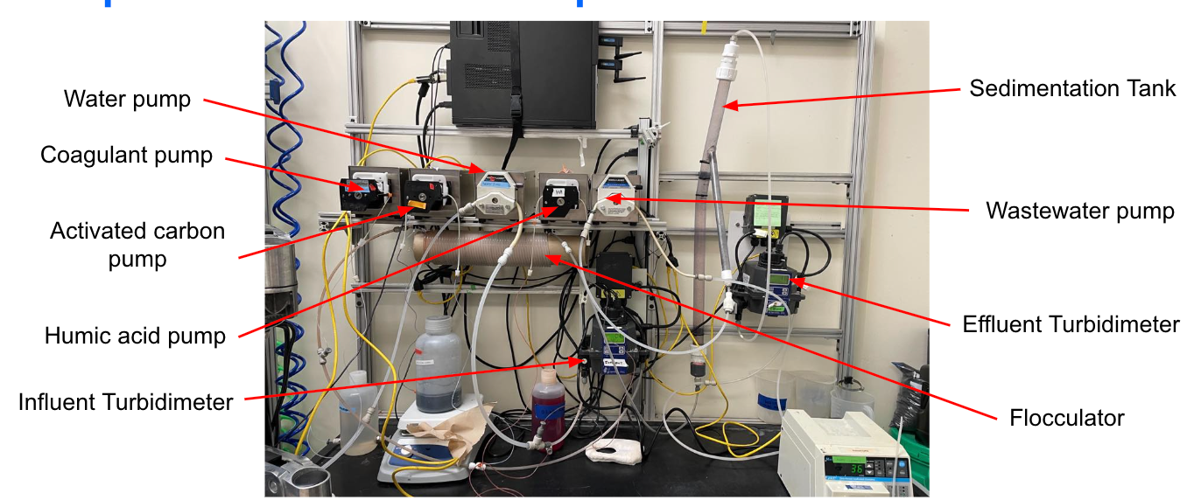

Figure 1: Image of lab set-up and experimental design

The experiments require the following materials: water pump, coagulant pump, activated carbon pump, humic acid pump, influent turbidimeter, sedimentation tank, wastewater pump, effluent turbidimeter, and a flocculator. In the experiment, the dependent variable is the turbidity and the independent variable is coagulant dosage. The humic acid concentration, flow rate of water, and run-time are held constant.

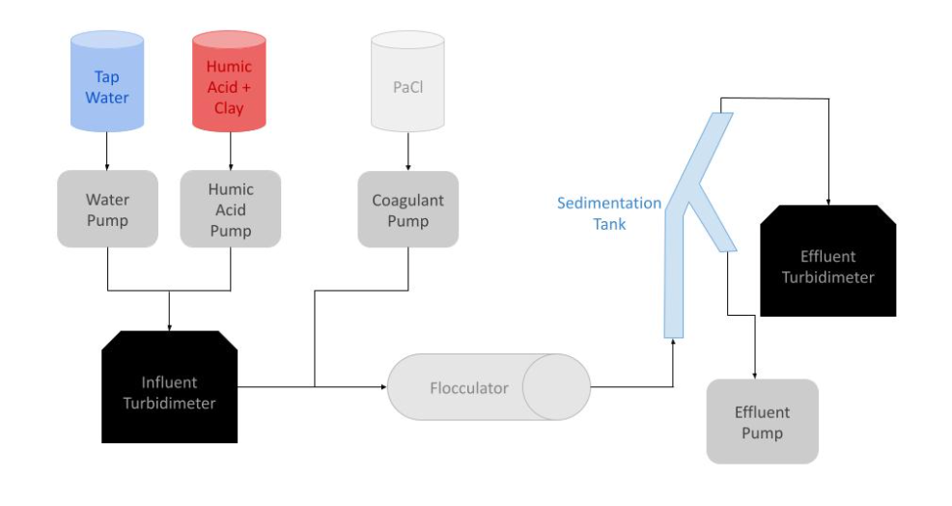

Figure 2: Schematic drawing of the experimental set up for testing varying humic acid, coagulant, and clay concentrations

In Figure 2, the independent variable is the coagulant (PACl) concentration. The humic acid concentration, flow rate of water, and run-time are held constant. The experiment begins by adding clay to the humic acid solution. The humic-acid-clay solution is then pumped in simultaneously with water so that they combine before entering the influent turbidimeter. Next, the coagulant pump adds PACl to the humic acid water mixture before it enters the flocculator. In the flocculator, the contaminants clump together to form dense flocs. The mixture then enters the sedimentation tank where the flocs will travel down the angled sloping branch due to gravity, while the clean water particles will rise to the top. The clean water then enters the effluent turbidimeter which measures the dependent variable: turbidity of the water. When the experiment runs properly, the turbidity reading on the effluent stream should be smaller than the turbidity reading on the influent stream.

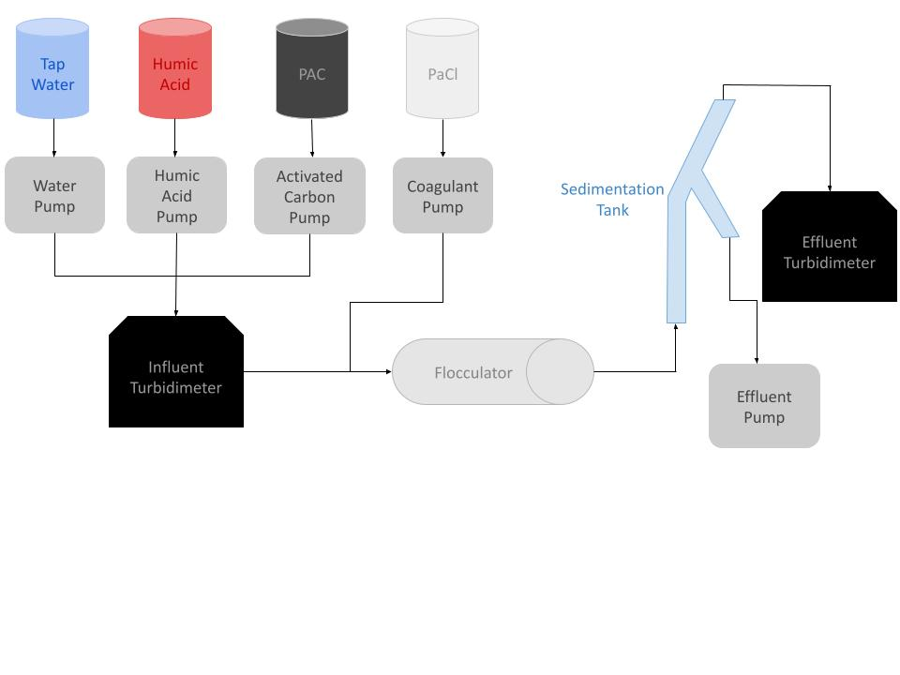

Figure 3: Schematic drawing of the experimental set up for testing varying humic acid, coagulant, and PAC concentrations

The experimental setup in Figure 3 is essentially the same as Figure 2, except that it replaces clay with activated carbon. In Figure 3, clay is never added to the humic acid solution—the clay concentration is zero. Figure 3 also contains an extra pump which contains activated carbon. Instead of clay, the activated carbon (PAC) will combine with humic acid and water before entering the influent turbidimeter.

To prepare the coagulant solutions necessary for the trials, dilutions using a micropipette and volumetric flasks are needed to dilute stock coagulant solution at 72 g/L. The formula employed to do the calculations is:

C1V1 = C2V2,

where C1: initial concentration (mg/L)

C2: final concentration (mg/L)

V1: volume of stock solution (L)

V2: volume of final solution (L)

**Table 3.** Dilution volumes and measurements of coagulant.

|  |  |  |
| --- | --- | --- |
| **Volume of stock solution (L)** | **Final volume (L)** | **Final concentration (mg/L)** |
| 42 * 10-6 | 1.0 | 3.0 |
| 56 * 10-6 | 1.0 | 4.0 |
| 69 * 10-6 | 1.0 | 5.0 |
| 138 * 10-6 | 1.0 | 10.0 |

To get 1.0 L of 3.0 mg/L, 42 μL of 72 g/L coagulant stock is extracted using a micropipette and put into a 1-L volumetric flask. Water is added to fill the flask to 1 L. After mixing, the resulting solution is at the final concentration of 3.0 mg/L of coagulant. The following dilutions are conducted using the same procedure with their corresponding volumes of stock solution in the table above.

**Results, Analysis, and Discussion**

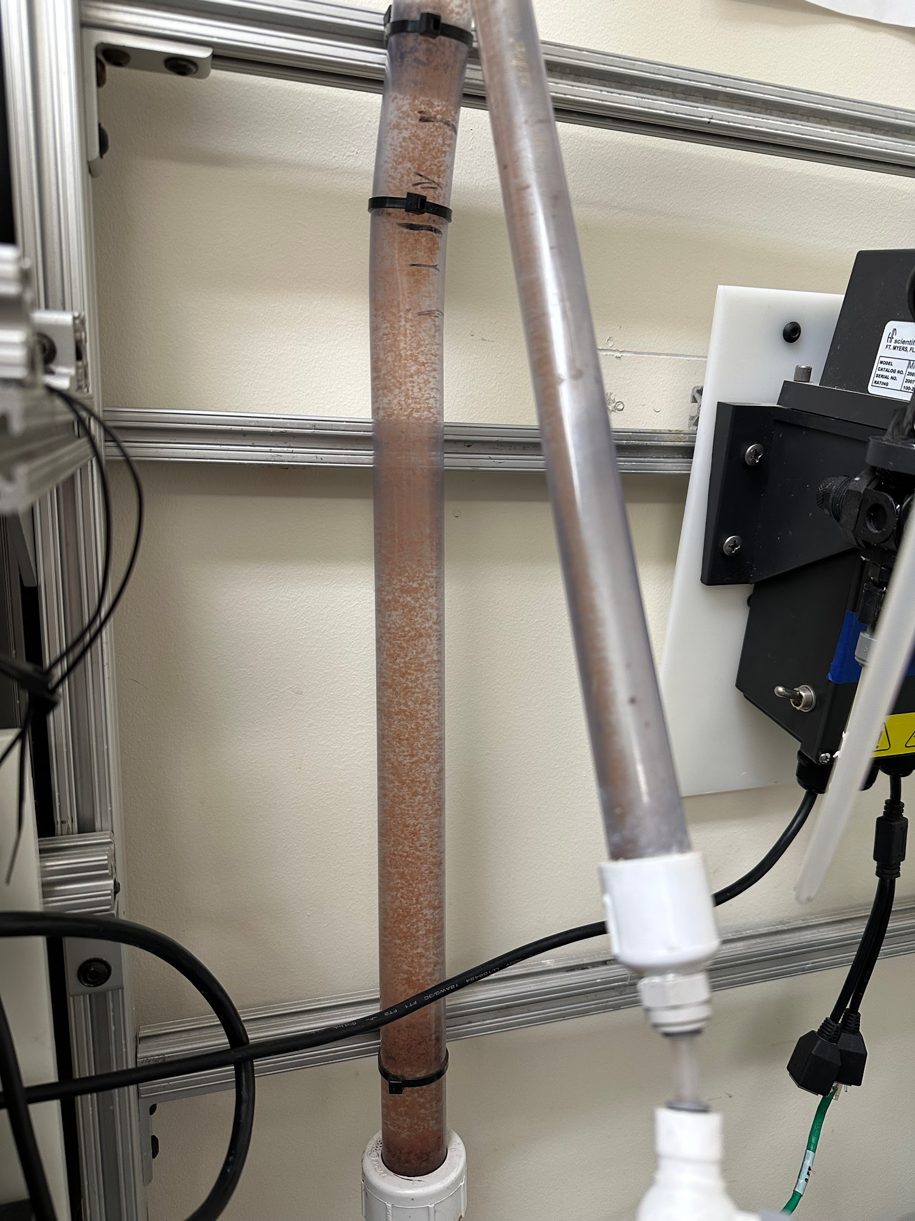

Figure 4: Image of sedimentation tank from experiments from last semester

The figure above shows how flocs ideally form in clean water. To increase visibility for making qualitative observations, red dye was added to the humic acid solution. The dye adhered to the humic acid resulting in a multitude of red-colored flocs. These flocs would go on to be separated in the separation tank. The leftover water was clear and transparent; the dye did not adhere to the water.

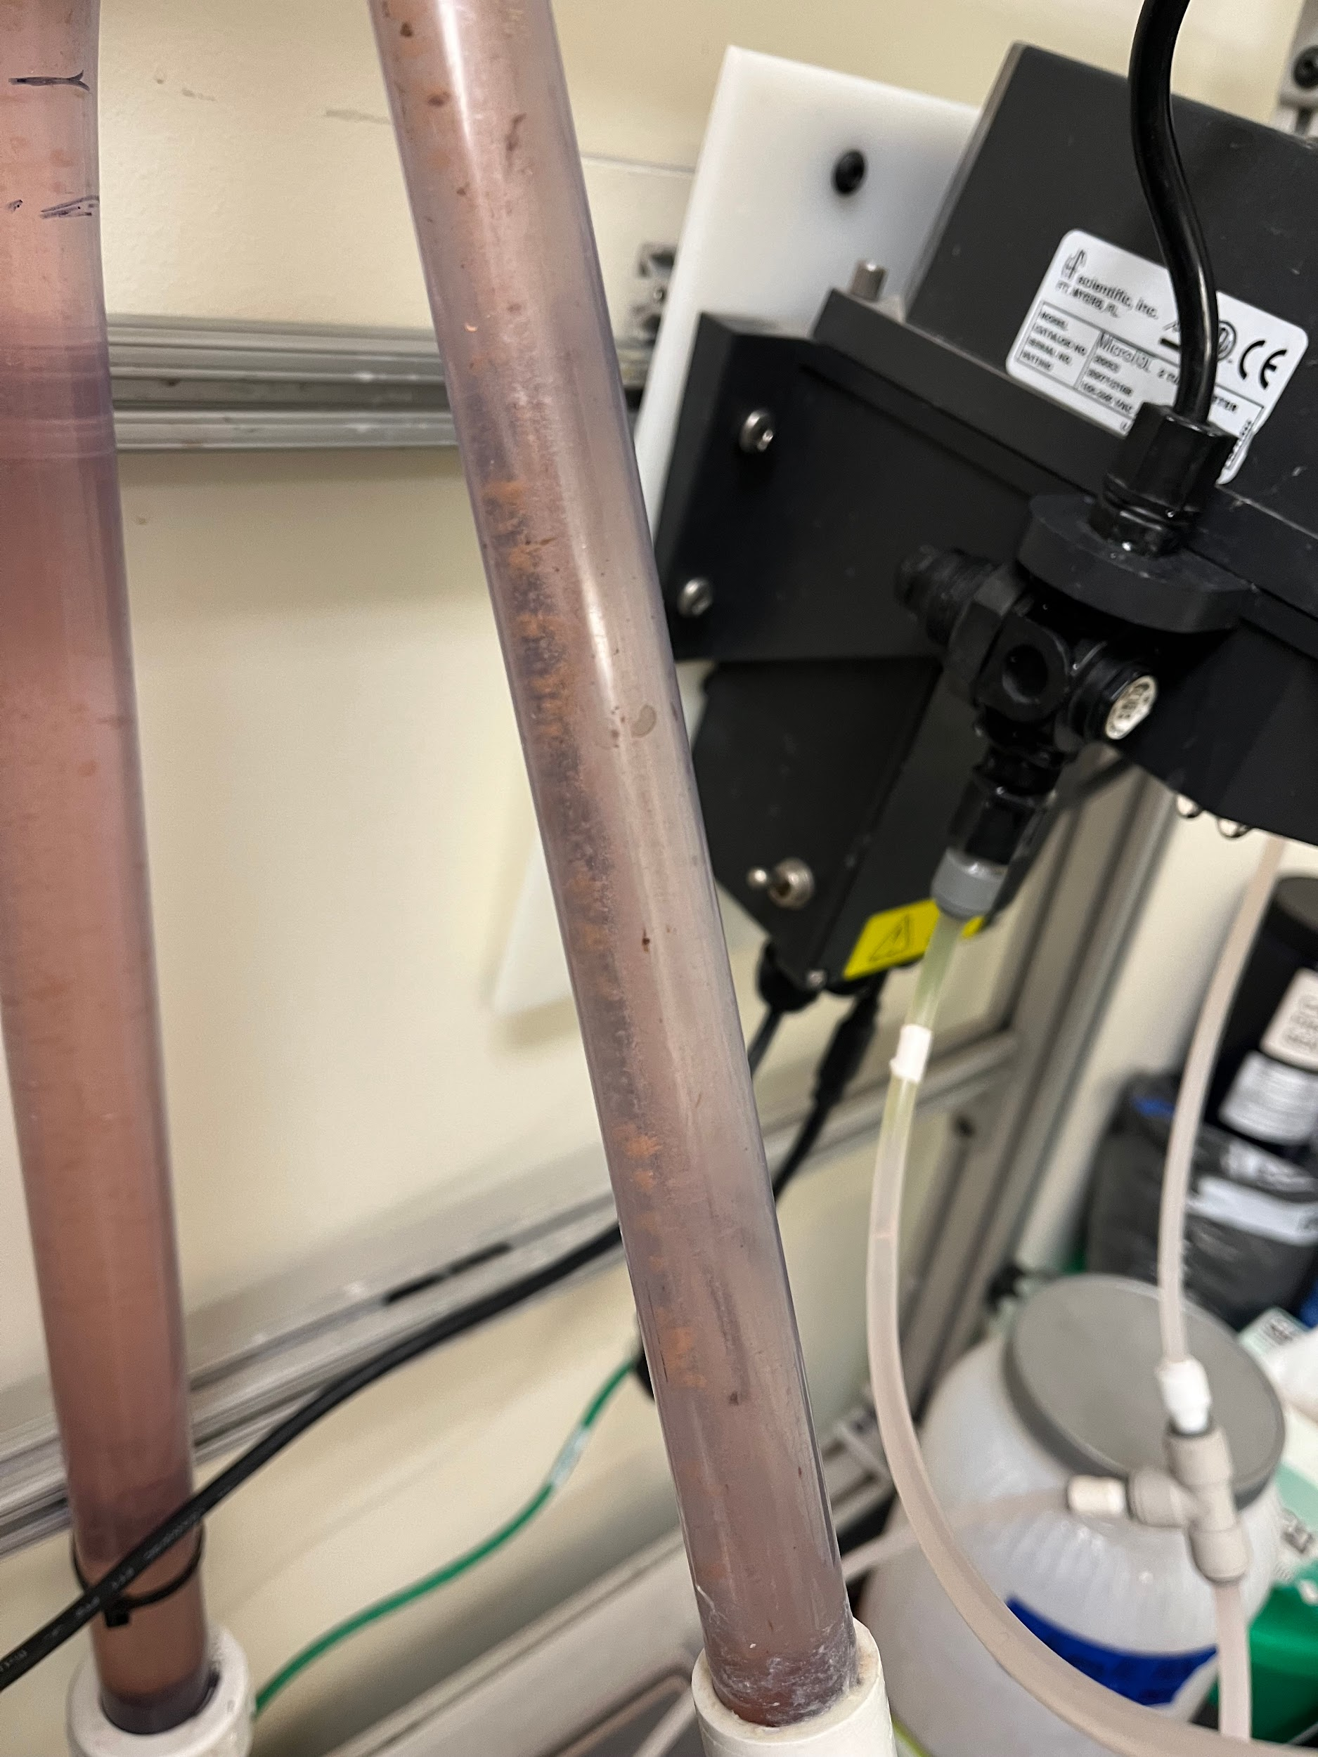

Figure 5: Run with 100 mg/L of PACl and 5 g/L of clay with 5 mg/L of humic acid

However, when this experiment was run with the current solutions as described in Figure 5, the water in the sedimentation tank was red and the suspended particles remained not colored. Even when the coagulant dosages for the trials were much higher than those mentioned in Table 2 (like in Figure 5), the results were such. These results were unexpected because the coagulant dosage for the trial run shown in Figure 5 was 100 mg/L, which is much higher than the values that had been reported to work in previous years for 5 mg/L of humic acid (1.6-1.8 mg/L PACl from Table 1). Based on the respective colors of the water and suspended particles, it was concluded that either the humic acid was not forming flocs or the dye was not adhering to the flocs. Since the additional coagulant caused the formation of more white particles, the white particles could indeed be flocs. Additionally, whether or not the dye was lab based or traditional food coloring, the same white particles were produced.

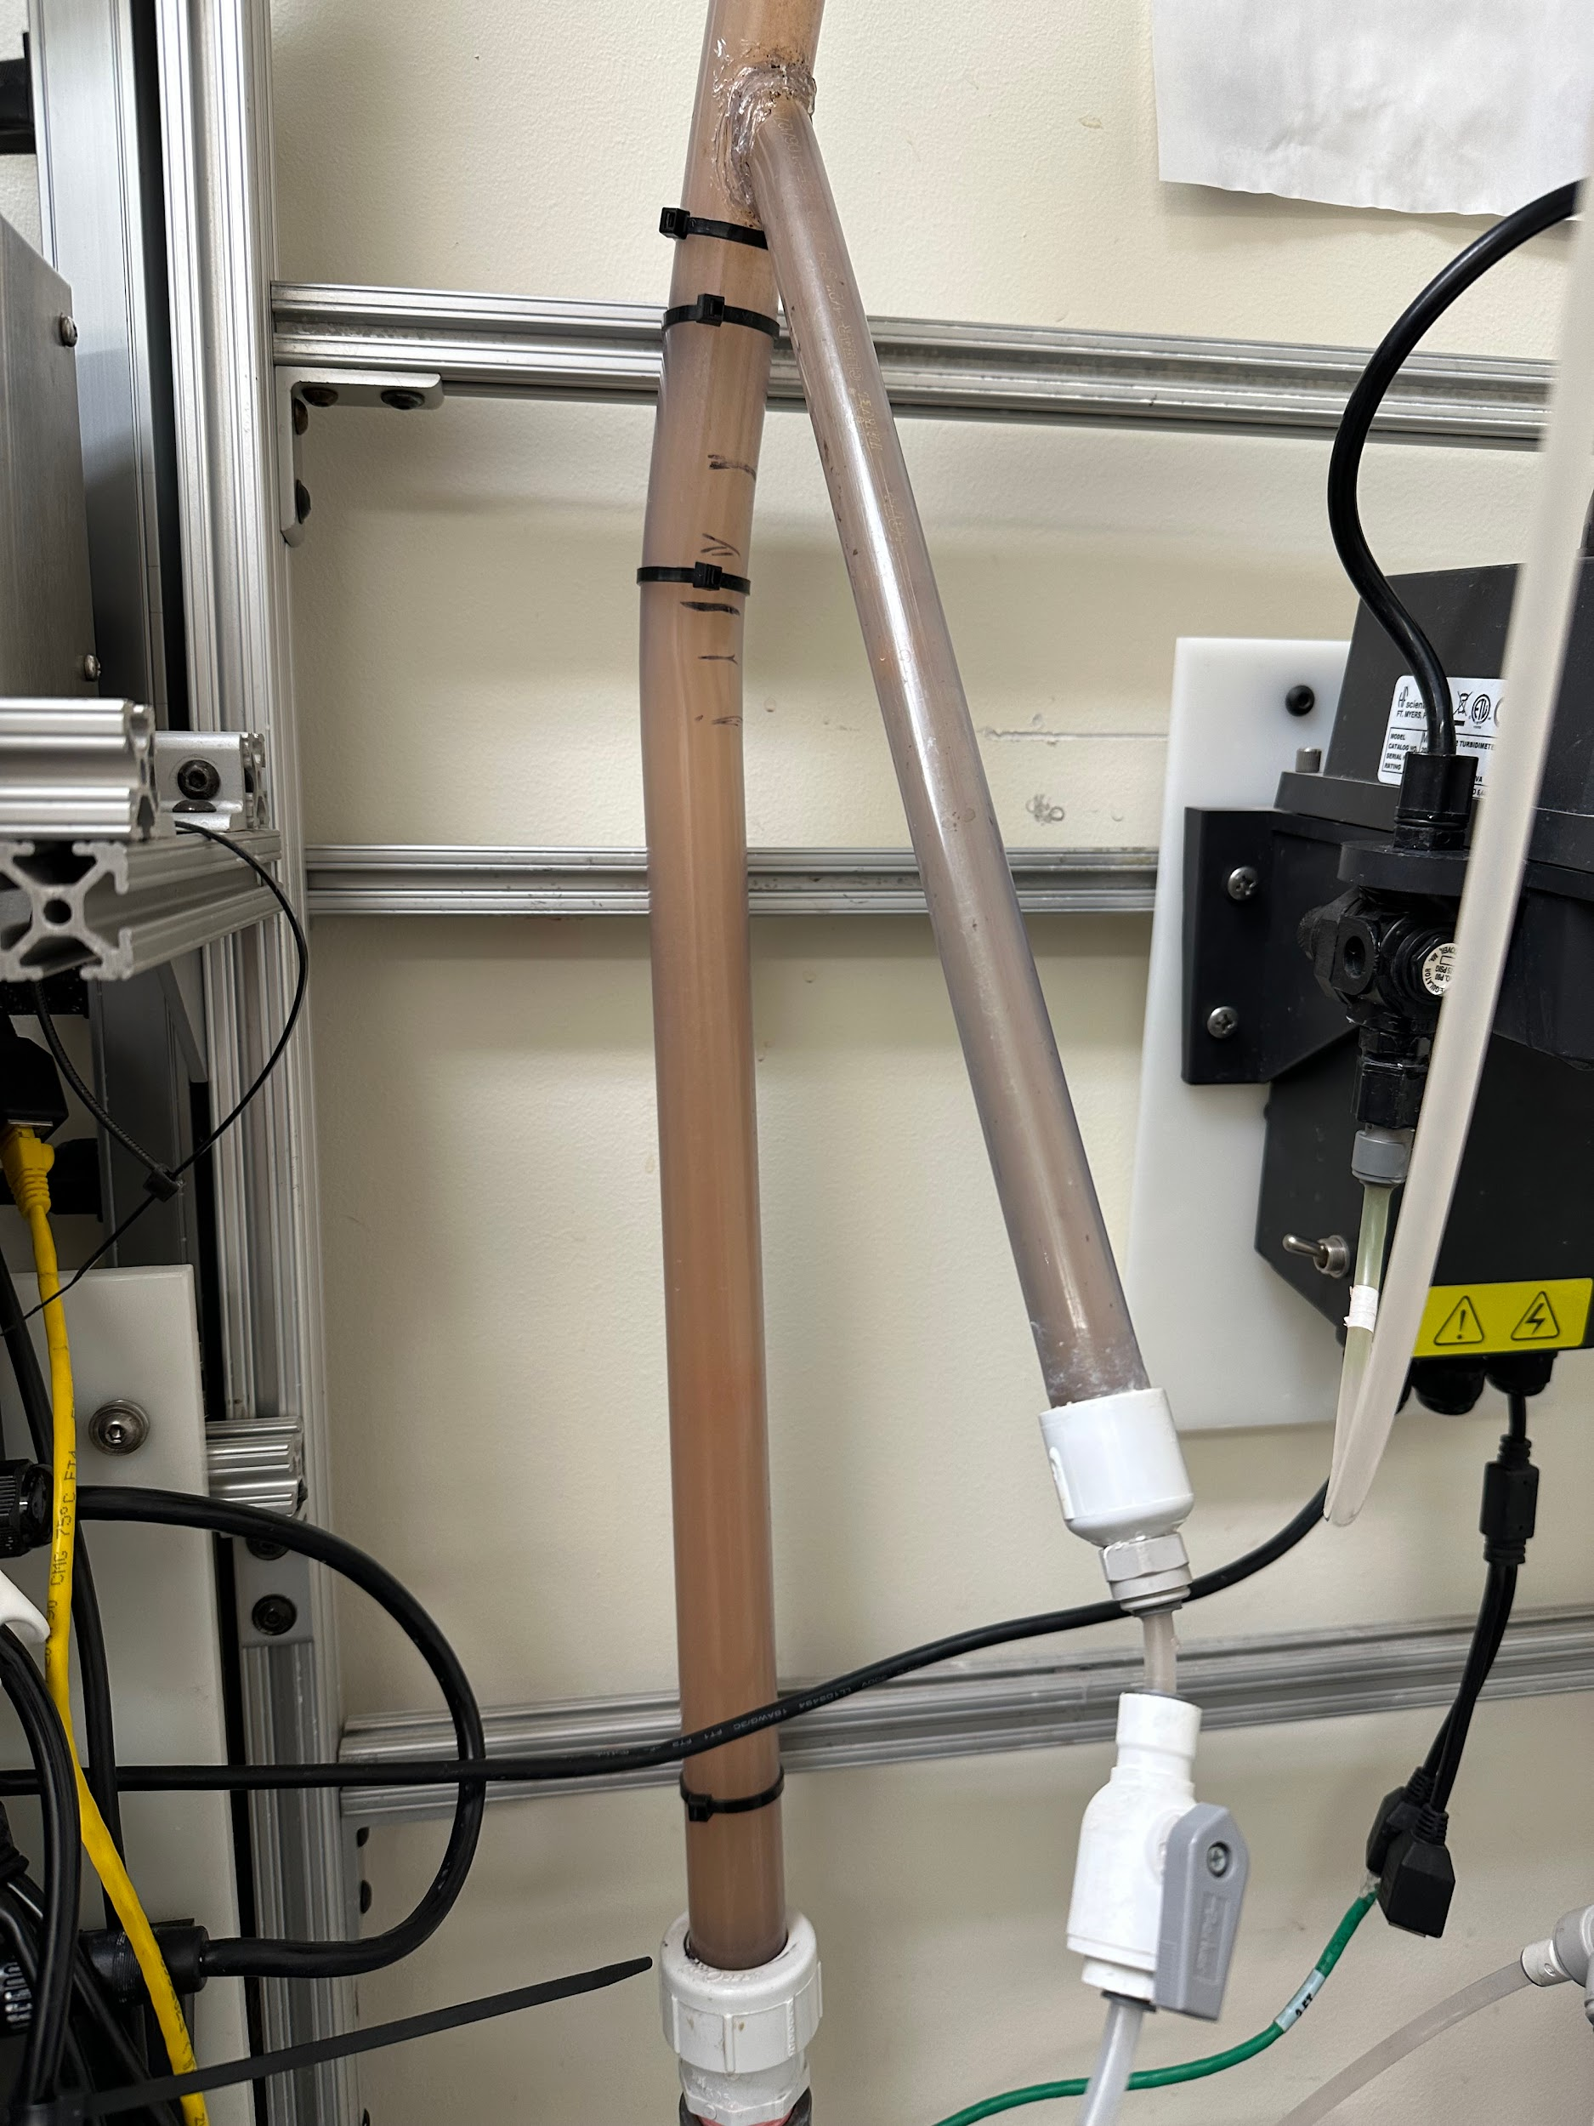

Figure 6: Run with 720 mg/L of PACl and 10 g/L of clay with 5 mg/L of humic acid

The purpose of this trial was to identify why flocs were not forming: was the issue that humic acid was failing to form flocs or that the food coloring dye was failing to adhere to the flocs? For this trial, the amount of coagulant used was significantly increased—the previous experiments ran with 100 mg/L of PACl, while this one was run with 720 mg/L. Additionally, the amount of clay was increased by a factor of two. Also, the dye used was lab-grade instead of traditional food coloring dye. The expectation was that there would be more particles (due to the increased coagulant) and they would be colored, while the water would be clear. The results of the experiment showed orange, murky water. The murkiness of the water prevented the flocs from being seen, leading to the results of the experiment being inconclusive. Future work entails experimenting with other factors, such as pH and flow rate, to determine the root of the issue.

**Conclusion**

As can be seen in the data analysis section, testing with large amounts of coagulant (i.e., 100 mg/L and 720 mg/L PACl) did not form dyed flocs like those shown in Figure 4. Even after changing the type of dye from food coloring to lab-grade, the flocs did not form as expected. This subteam’s future work will focus on investigating why flocs are not forming well.

One of the major tasks is to vary the concentrations of humic acid and the coagulant (PACl) to prove that there is a positive relationship among both solutions. This is a continuation of the work done by the humic acid subteam, which researched the same relationship. Literature review indicates that the optimal dosage should increase as the concentration of humic acid increases. However the humic acid team found that when humic acid concentrations were 5 and 10 mg/L, there was a negative relationship (See Table 1). For humic acid concentration of 5 mg/L the optimal dosage was 1.6-1.8 mg/L, while for humic acid concentration of 10 mg/L the optimal dosage was 1.3 mg/L. As such, future experiments intend to establish that the previous data from the Humic Acid subteam contained an anomaly and prove the aforementioned positive relationship.

Another task that will be focused on in the next semester is using activated carbon in the experimental procedure to see if it can provide turbidity while having an enhanced effect in forming flocs. The experiments will involve using the same concentrations of humic acid that was tested with its corresponding optimal coagulant concentrations, and varying the concentrations of clay and activated carbon.

**References**

AguaClara Cornell. (2018). *Procoda*. ProCoDA - AguaClara Tutorial v0.1.0 documentation. Retrieved October 23, 2022, from https://aguaclara.github.io/aguaclara_tutorial/research/procoda.html

Biswas, S., Fatema, J., Debnath, T., & Rashid, T. U. (2021). Chitosan–Clay Composites for wastewater treatment: A state-of-the-art review. ACS ES&T Water, 1(5), 1055–1085. https://doi.org/10.1021/acsestwater.0c00207

Campos, C., Snoeyink, V. L., Mariñas, B., Baudin, I., & Lainé, J. M. (2000). Atrazine removal by powdered activated carbon in floc blanket reactors. *Water Research*, *34*(16), 4070–4080. https://doi.org/10.1016/s0043-1354(00)00169-x

Lai, R., Hsu, A., Shin, L., & Wu, D. Humic Acid, Fall 2021. Retrieved from

https://github.com/AguaClara/humic_acid/blob/master/Fall%202021/Humic_Acid_Fall_2021_Final_Report.ipynb

Lai, R., Kim, A., & Crites, E. Humic Acid, Spring 2022. Retrieved from

https://github.com/AguaClara/humic_acid/blob/master/Spring%202022/Humic%20Acid%20Spring%202022%20Final%20Report.ipynb

Lillie, I., Hsu, A., Nguyen, N., & Kwon, Z. Activated Carbon, Spring 2022. Retrieved from https://github.com/AguaClara/activated_carbon/blob/master/Activated_Carbon_Spring2022_Final_Report.ipynb

Saxena, K., Brighu, U., & Choudhary, A. (2021). Experimental investigation and modeling the effect of humic acid on coagulation efficiency for sludge blanket clarifier. *Chemosphere*, *266*, 128958. https://doi.org/10.1016/j.chemosphere.2020.128958

Tafvizi, H., Chowdhury, S., & Husain, T. (2021). Low cost activated carbon for removal of NOM and dbps: Optimization and comparison. *Water*, *13*(16), 2244. https://doi.org/10.3390/w13162244

Wu, Z., Zhang, X., Pang, J., Zhang, X., Li, J., Li, J., & Zhang, P. (2020). Humic acid removal from water with pac-al30: Effect of calcium and kaolin and the Action Mechanisms. *ACS Omega*, *5*(27), 16413–16420. https://doi.org/10.1021/acsomega.0c00532